Advancement to Candidacy - Committee
Students can submit this form to create or change their committee for a Qualifying Exam or Advancement to Candidacy. The form should be submitted at least three weeks in advance.
The following shows the steps necessary for creating an Advancement to Candidacy committee.

Navigate to Cal Central > Student Resources > Committees | 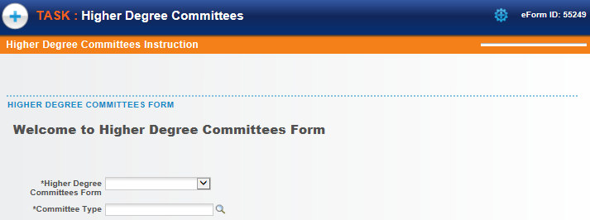
Select the form to fill out.  In this example, we will create an Adancement to Candidacy committee. | 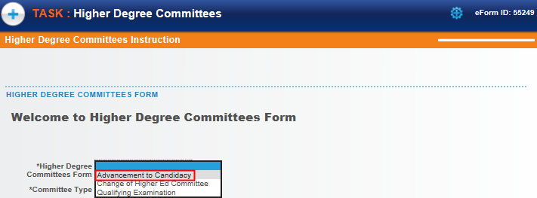
Then click the Committee Type lookup icon to select a choice.  Depending on which program the student is enrolled in, the choice will either be Masters (Plan 1) or Doctoral.  In this example, we’ll select Doctoral. | 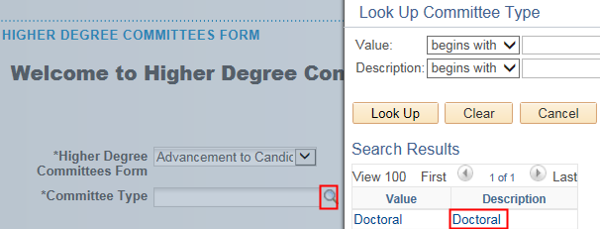
Once the type of form is selected, the system will run an eligibility check.  If the student is eligible, an introduction will display, as well as a Next button.  If the student is ineligible, a message will display explaining why the student is not eligible.  Click the Next button to proceed. | 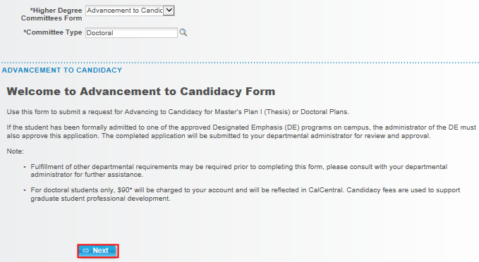
The form will load.  The first 2 sections will display Student Information, as well as the student’s Academic Programs and Plans. | 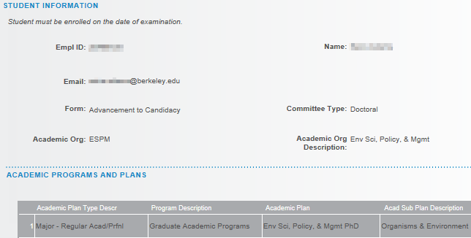
Next, select the three Committee Members. (Note: Some departments may require more.)  Make sure to read through and follow the instructions. | 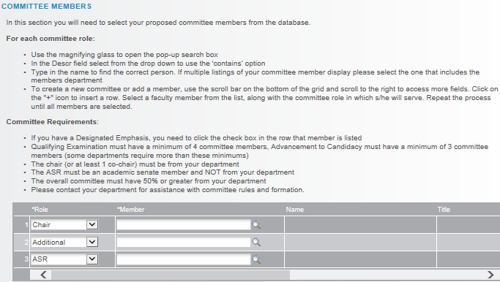
To add a committee member, we’ll select a Role and lookup the name.  Accept the default or select the appropriate Role from the drop-down list.  Do not type in the Name, we must select from an already existing list.  Click the lookup icon to search for the person.  In the Description field, change the search to “Contains”. We can then search by first or last name or even by the department name (e.g. Art).  All current and former faculty, students and committee members are available to search, but if a new person needs to be added (e.g. a UCSF professor who has never served on a committee), contact Graduate Division to add them. | 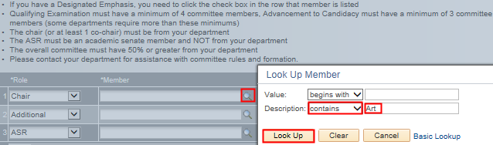
After selecting a person, their Campus Solutions ID# will appear, as well as their name and job title.  Scroll right to see more columns. | 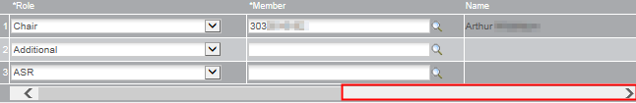
If the person is a Designated Emphasis Representative, check the DE Rep box.  The system shows a checkmark for anyone in the Academic Senate.  The plus/minus buttons allow us to add or delete someone. | 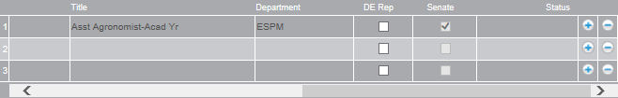
The ASR (Academic Student Rep) must be from another department and a member of the Academic Senate.
Scroll over and verify the Senate box has a checkmark. Otherwise, we’ll receive an error at the end.
If a member is added who is not in the Academic Senate the next section will also need to be filled out, and a CV will need to be uploaded below.  This will require approval by Graduate Division (in addition to the advisor). | 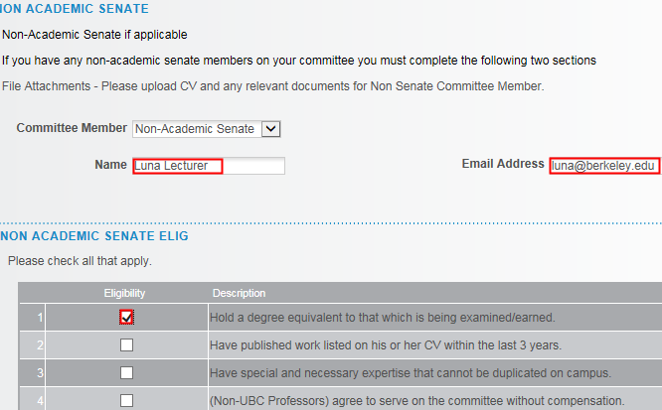
In the Human and Animal Subjects section, select the appropriate response.  In our example, our research does not involve human or animal subjects, so we will select Option 1. | 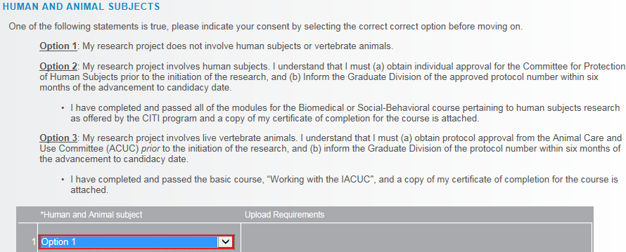
In the Exceptions section, select either Yes or No.  If we select Yes, we’ll see some warnings but can still proceed. | 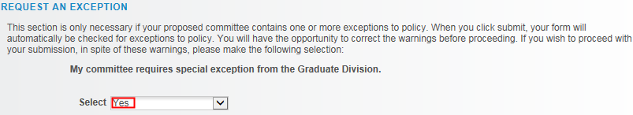
Int he File Attachments section, upload any relevant documentation. (e.g. a CV or an explanation of why an exception is needed). | 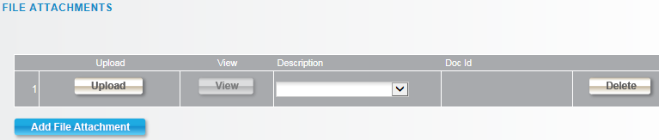
To add Comments, click the grey arrow to expand the comments box.  Type in comments. | 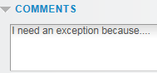
If finished, click the Submit button.
A confirmation page shows that the form has been routed to our Graduate Advisor for review and approval.  If our committee requires an exception from Graduate Division, we’ll see them listed as well.  . | 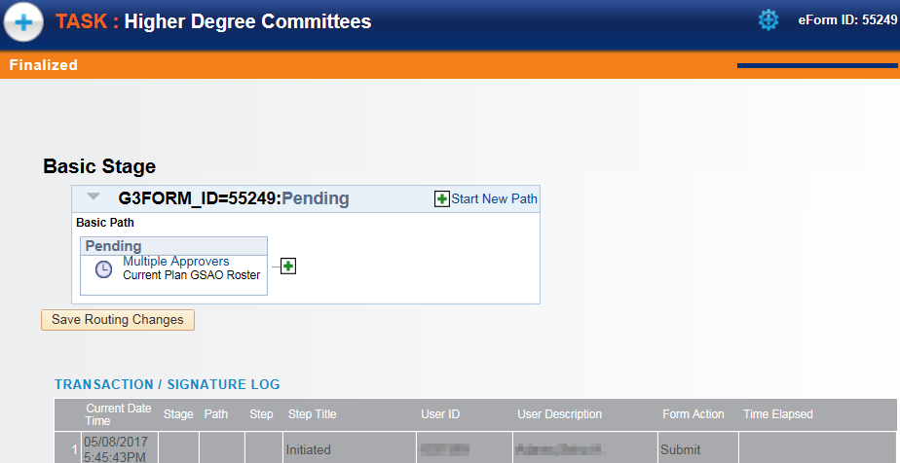
ADVISOR APPROVAL
An advisor will receive an email notifying them there is a Committee to approve.
Navigate to Cal Central > Advising Resources > eForms Action Center | 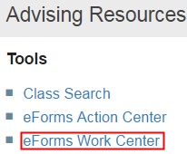
Click Evaluate a Student eForms | 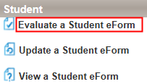
Search by the Form ID (in the email subject line) or leave the fields blank and Search to see all pending forms that need reviewing.  (Note: If there is only one form needing review, it will open directly). | 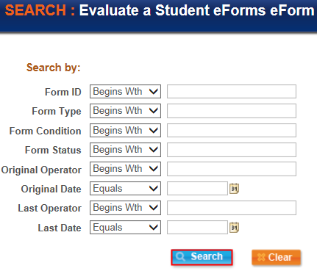
The introductory page displays.  Scroll down and click the Next button. | 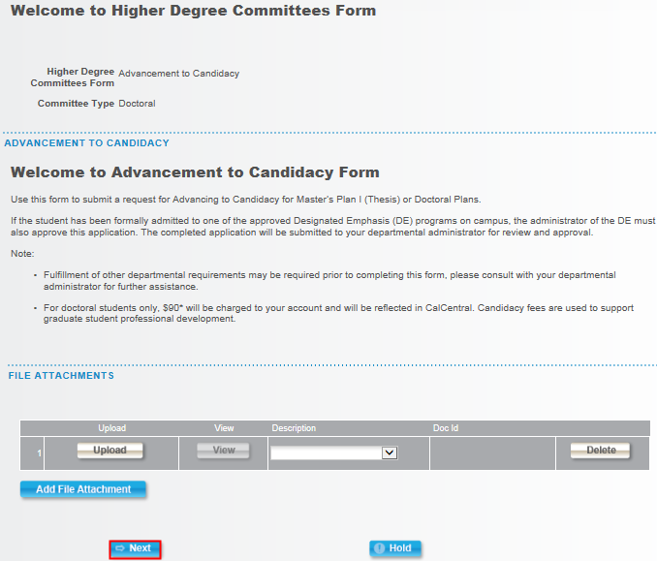
The Advancement to Candidacy Committee eform displays.  At the top is information about the student and their plan. | 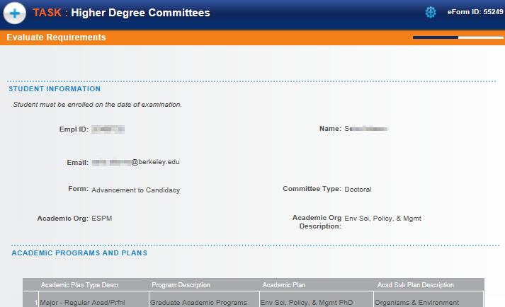
Review the Committee Members.  Scroll to the right to see if there is a Designated Emphasis member and whether the members are in the Academic Senate. | 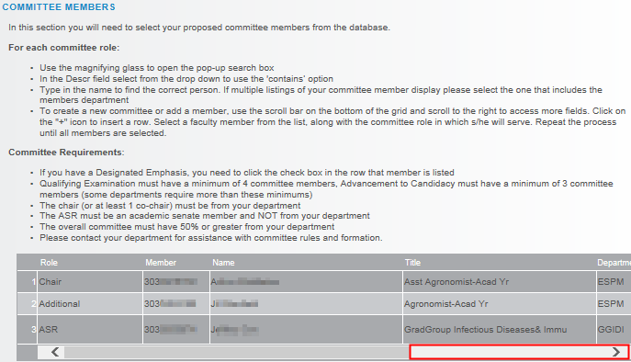
Note: Advisors can not make changes to the Committee. | 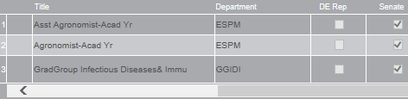
If any of the members were not in the Academic Senate, we would need to review the next two section. | 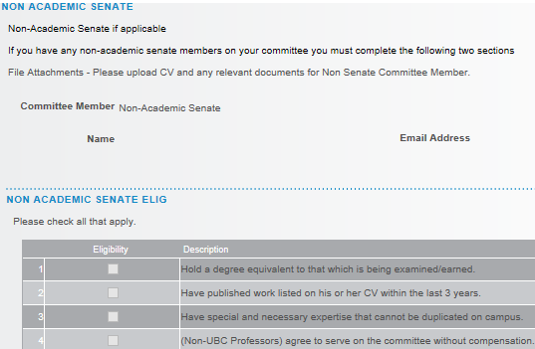
Review the selected Human And Animal Subjects option. | 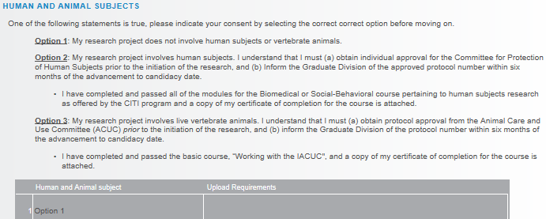
Review any Exceptions and File Attachments.  If needed, we can upload a new File Attachment.  When we are finished, click Approve or Deny as appropriate. | 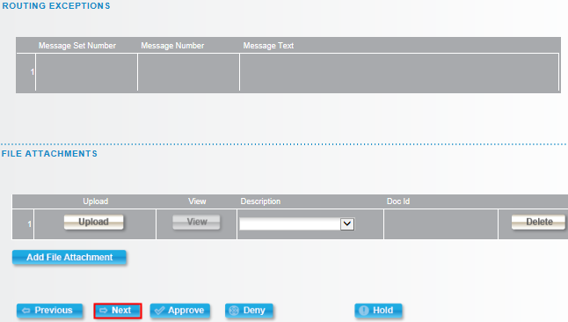
A transaction log will record our approval.  If there is an additional approval step needed, the system will route to the next approval. If this is the final approval, the student will receive an email that his/her committee has bee approved. | 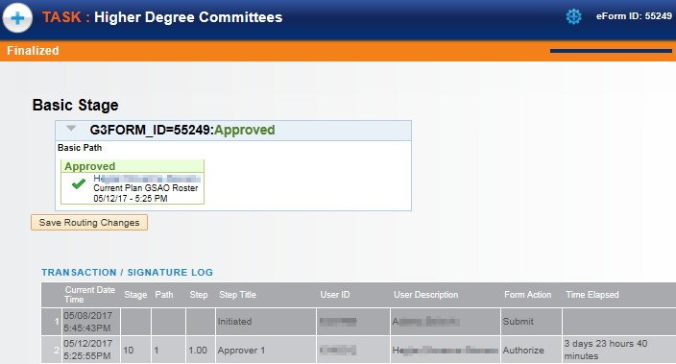

Support
For questions related to policy and procedures, students should refer to their department or to Graduate Division.
http://grad.berkeley.edu/about-us/contact/
For technical questions or assistance, please contact SIS Support.:
- Call 510-664-9000 (press option 6 to reach SIS support)
- Email: sishelp@berkeley.edu
- Submit a ticket: https://berkeley.service-now.com/ess/create_incident

