Changing a Committee
Students can submit this form to create or change their committee for a Qualifying Exam or Advancement to Candidacy. The form should be submitted at least three weeks in advance.
The following shows the steps necessary for making changes to an already submitted committee. This form will allow students to add or remove committee members, and change their roles.
Navigate to Cal Central > Student Resources > Committees | 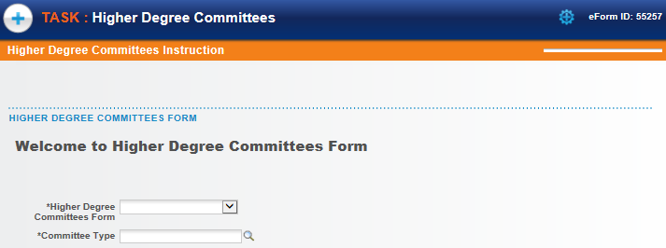
Select the form to fill out.  In this example, we will select Change of Higher Ed Committee. | 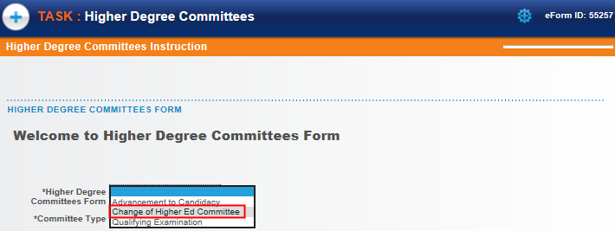
Then click the Committee Type lookup icon to select a choice.  Depending on which program the student is enrolled in, the choice will either be Masters (Plan 1) or Doctoral.  In this example, we’ll select Doctoral. | 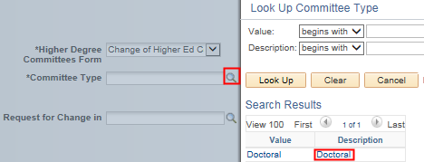
Click the Request for Change In lookup icon to select a choice.  In this case we will click on Doctoral. | 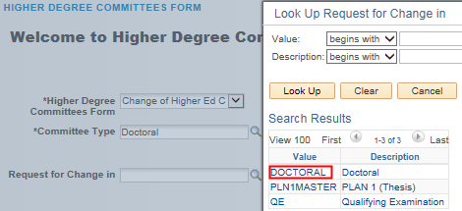
Once the type of form is selected, the system will check for an existing committee.  Click the Next button to proceed. | 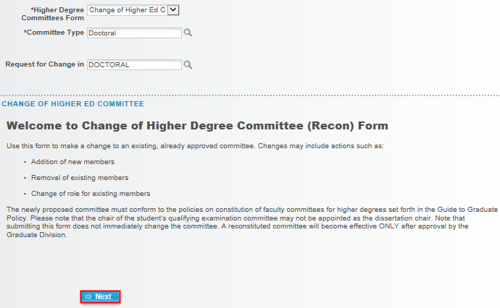
The form will load.  The first 2 sections will display Student Information, as well as the student’s Academic Programs and Plans. | 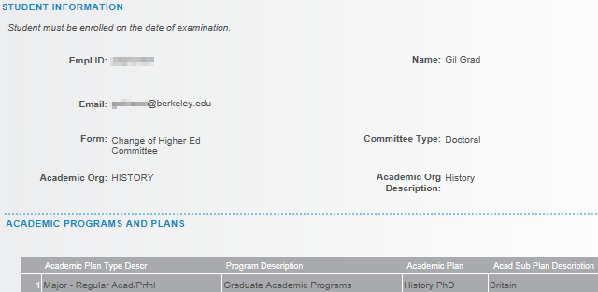
The current Committee Members are listed.  To delete a member, click the Remove box to the left. | 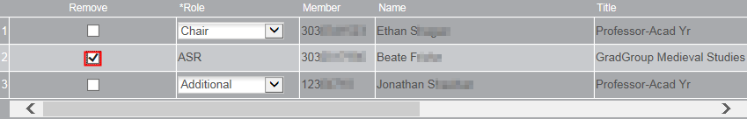
To add a committee member, we’ll scroll to the right to find the plus buttons. | 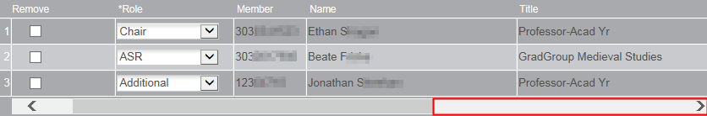
Click a plus button to add a new line. | 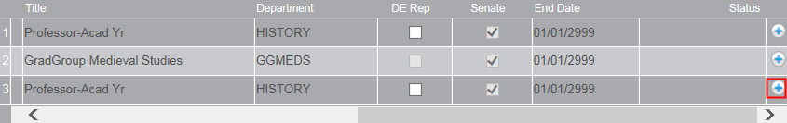
We’ll have to scroll back over to the left to fill out the new row. | 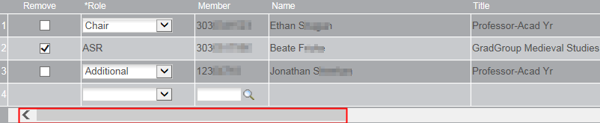
Select the appropriate Role from the drop-down. In this example, we are adding a new ASR.  Do not type in a Name, we must select from an already existing list.  Click the lookup icon to search.  In the Description field, change the search to “Contains”. Search by first or last name or by department.  All current and former faculty, students and committee members are available. To add a new person, contact Graduate Division. | 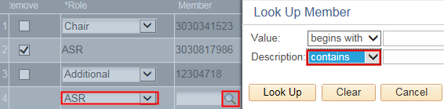  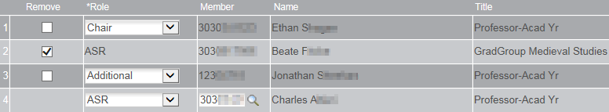
If a member is added who is not in the Academic Senate the next section will also need to be filled out, and a CV will need to be uploaded below.  This will require approval by Graduate Division (in addition to your advisor). | 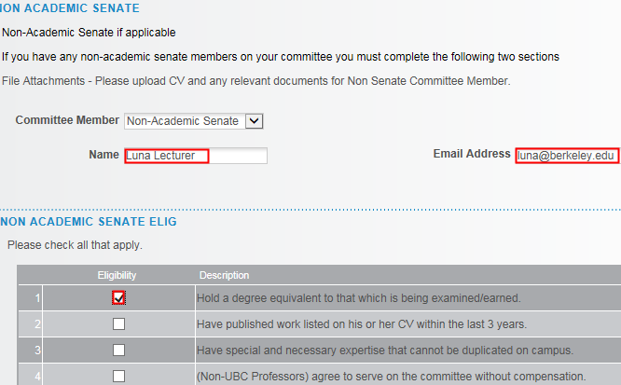
In the Exceptions section, select either Yes or No.  If we select Yes, we’ll see some warnings but can still proceed. | 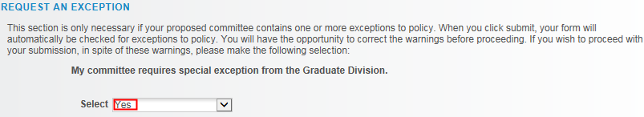
Int he File Attachments section, upload any relevant documentation. (e.g. a CV or an explanation of why an exception is needed). | 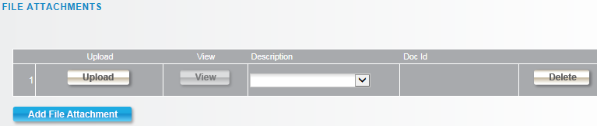
To add Comments, click the grey arrow to expand the comments box.  Type in comments. | 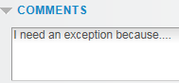
When finished, click the Submit button.
A confirmation page shows that the form has been routed to our Graduate Advisor for review and approval.  If our committee requires an exception from Graduate Division, we’ll see them listed as well.  . | 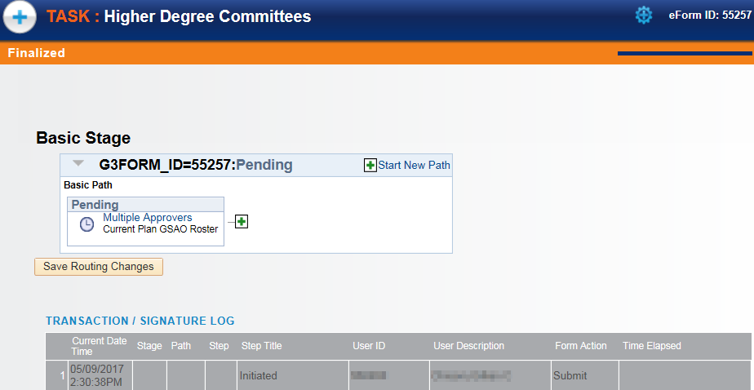
The student will receive an email confirmation of the submission. | 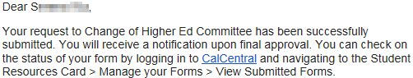
ADVISOR APPROVAL
An advisor will receive an email notifying them there is a Committee to approve. The subject line will reference a Form ID# that can be used to look up the form.
Navigate to Cal Central > Advising Resources > eForms Work Center | 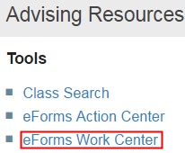
Click Evaluate a Student eForm | 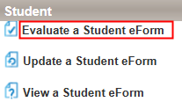
Search by the Form ID or leave the fields blank to Search all eforms awaiting our approval.  Note: If there is only one form, it will load directly. | 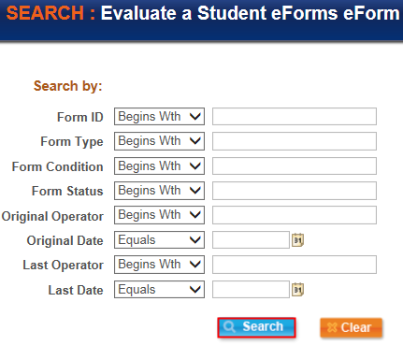
The Instruction page appears.  Scroll down and click Next. | 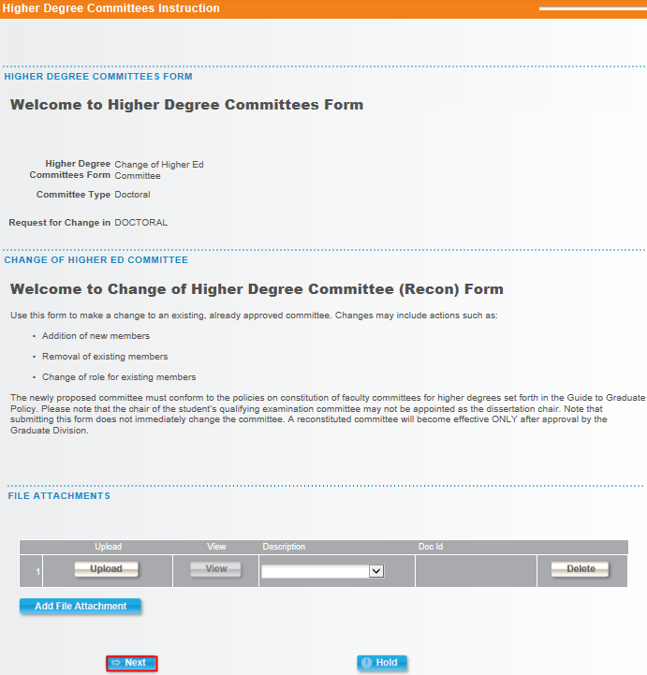
The form displays.  At the top of the page is the student’s information and plan. | 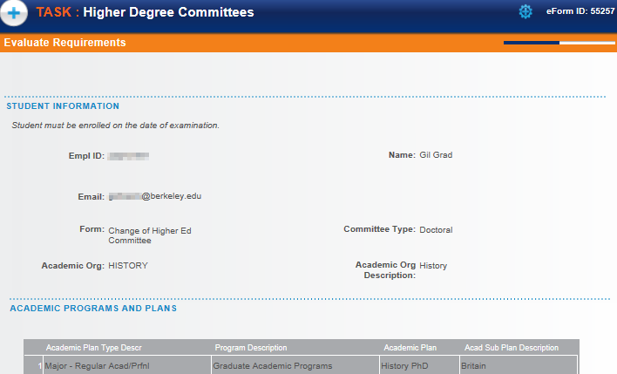
Review the Committee Members.  We can see who is to be replaced (there will be a checkmark in the Remove column) and who the new member is.  Note: Advisors can not add or delete members. | 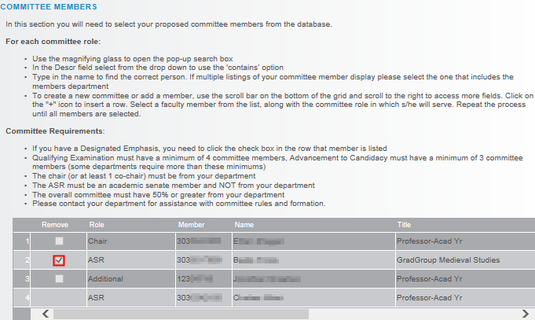
We may need to scroll to the right to check for a Designated Emphasis check mark and to see if the new committee member is a member of the Academic Senate. | 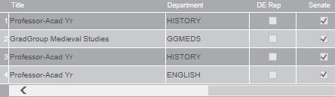
If the newest member is not in the Academic Senate, review the next two sections. | 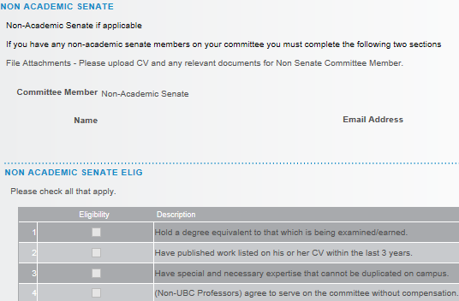
Review any Exceptions and File Attachments.  When finished, click the Approve or Deny button. | 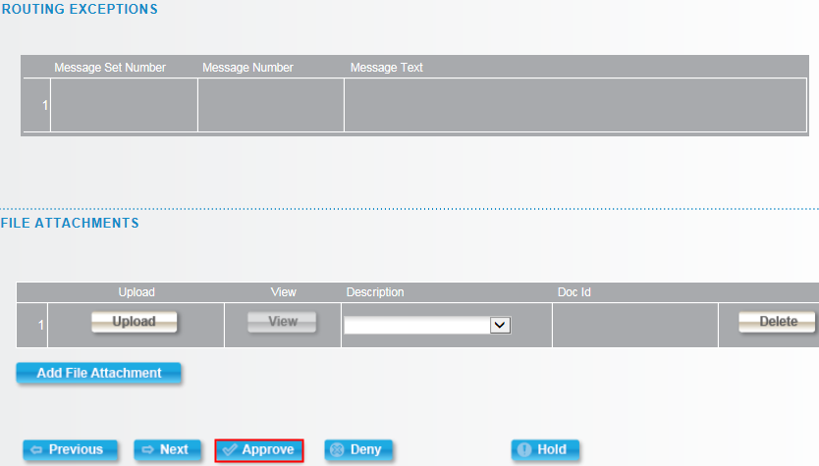
A confirmation page will show the transactions.  If another layer of approval is needed, the system will route to the next approver.  If this is the final approval, the student will receive an email confirmation with a subject line of “Higher Degree Committees eForm Request Approved - Form ID #####” | 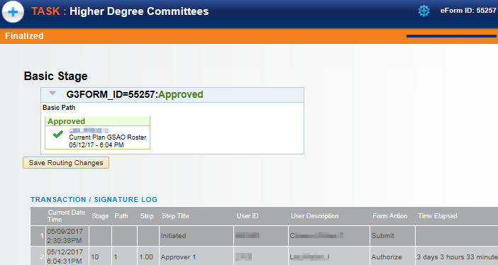

Support
For questions related to policy and procedures, students should refer to their department or to Graduate Division.
http://grad.berkeley.edu/about-us/contact/
For technical questions or assistance, please contact SIS Support.:
- Call 510-664-9000 (press option 6 to reach SIS support)
- Email: sishelp@berkeley.edu
- Submit a ticket: https://berkeley.service-now.com/ess/create_incident

