Qualifying Exam - Committee
Students can submit this form to create or change their committee for a Qualifying Exam or Advancement to Candidacy. The form should be submitted at least three weeks in advance.
The following shows the steps to create a Qualifying Exam committee.
Navigate to Cal Central > Student Resources > Committees | 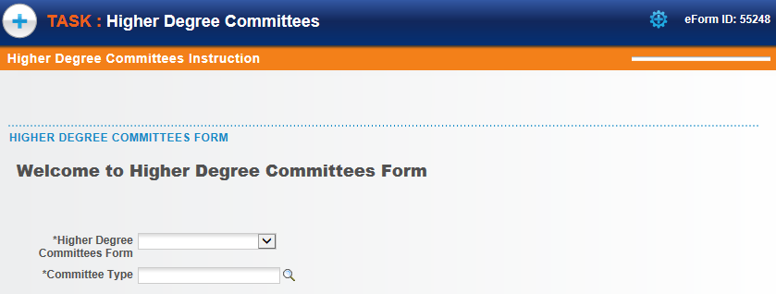
Select the form to fill out.  In this example, we will create a Qualifying Examination (QE) committee. | 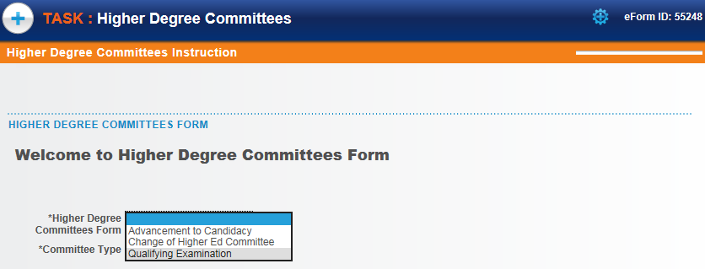
Then click the lookup icon to select a choice.  In this example, we’ll select Doctoral. | 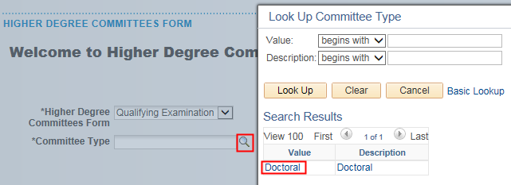
Once the type of form is selected, the system will run an eligibility check.  If the student is eligible, an introduction will display, as well as a Next button.  If the student is ineligible, a message will display explaining why the student is not eligible.  Click the Next button to proceed. | 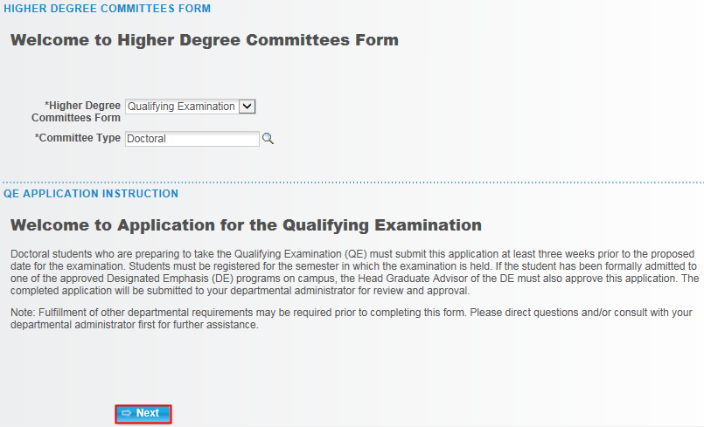
The form will load.  In the Student Information section, enter the Proposed Exam Date.  Fill in a date or click the calendar icon to pick a date. | 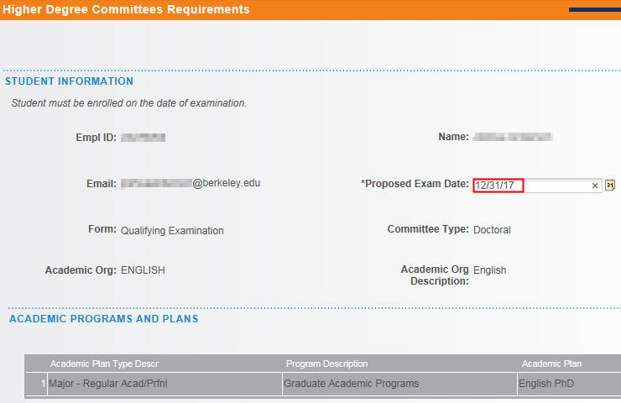
In the Subject Area section, fill in at least 3 subject areas. | 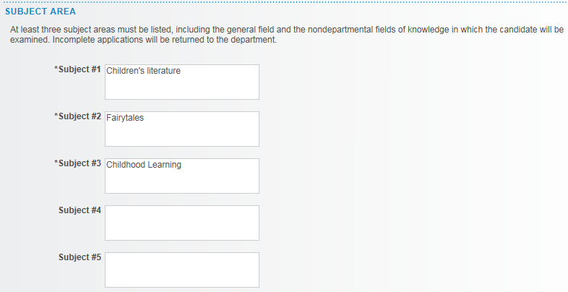
Next, select the four Committee Members. (Note: Some departments may require 5.)  Make sure to read through and follow the instructions. | 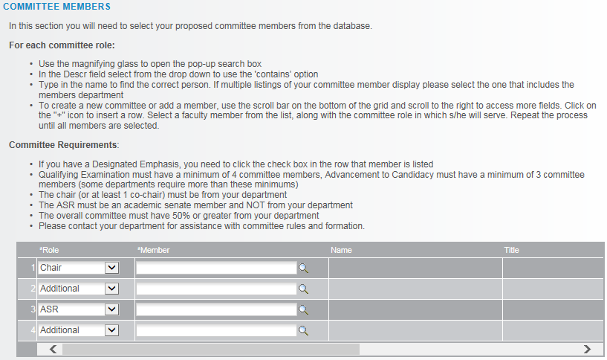
To add a committee member, we’ll select a Role and lookup  Accept the default or select the appropriate Role from the drop-down list.  Do not type in the Name, we must select from an already existing list.  Click the lookup icon to search for the person.  In the Description field, change the search to “Contains”. We can then search by the first or last name or even by the department name (e.g. English).  All current and former faculty, students and committee members are available to search, but should you need to have a new person added (e.g. a professor at UCSF who has never served on a committee), contact the Graduate Division to have them added. | 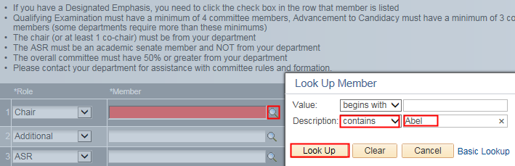
After selecting a person, their Campus Solutions ID# will appear, as well as their name and job title.  Use the scroll bar below to see more columns on the right. | 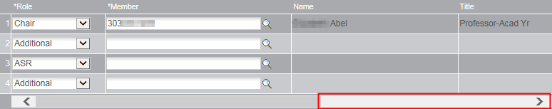
If the person is a Designated Emphasis Representative, check the DE Rep box.  The system will show a checkmark for anyone in the Academic Senate.  The plus/minus buttons allow us to add or delete someone from the committee. | 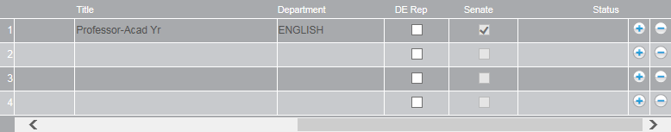
The ASR (Academic Student Rep) must be from another department and in the Academic Senate.  So make sure to scroll over and verify the Senate box has a checkmark. Otherwise, we’ll receive an error at the end. | 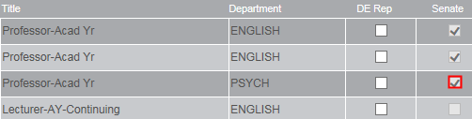
If a member is added who is not in the Academic Senate (our fourth choice) the next two sections will also need to be filled out, and a CV will need to be uploaded below.  This will require approval by Graduate Division (in addition to your advisor). | 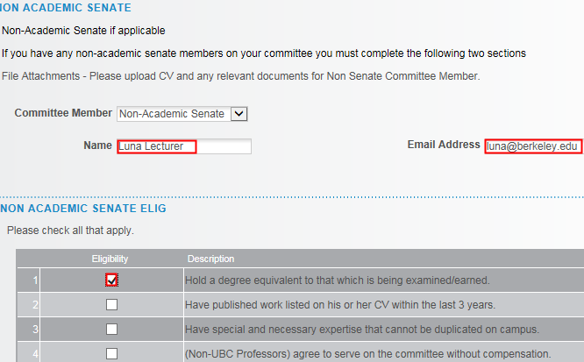
In the Exceptions section, select either Yes or No.  If we select Yes, we’ll see some warnings but can still proceed. | 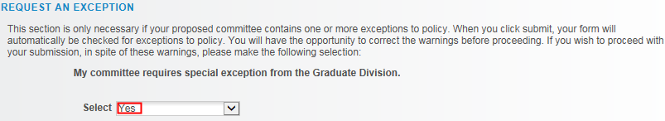
Int he File Attachments section, upload any relevant documentation. (e.g. a CV or an explanation of why an exception is needed). | 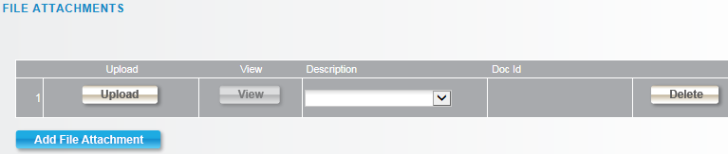
To add comments, click the grey arrow to expand the comments box.  Type in comments. | 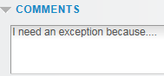
When finished, click the Submit button.
A confirmation page shows that the form has been routed to our Graduate Advisor for review and approval. If our committee requires an exception from Graduate Division, we’ll see them listed as well.  . | 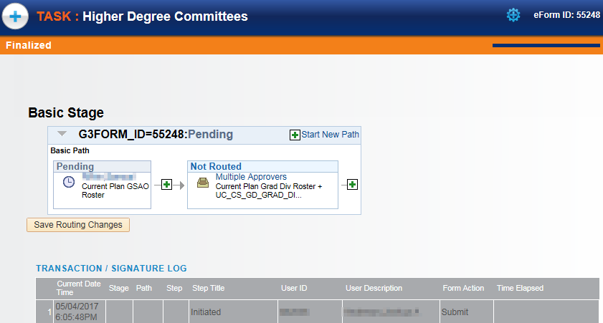
ADVISOR APPROVAL
An advisor will receive an email with subject line “Higher Degree Committees eForm Needs Review: Form ID #####”. | 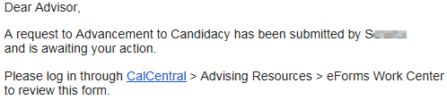
Navigate to Cal Central > Advising Resources > eForms Work Center |  | 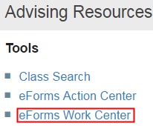
Click on Evaluate a Student eForm |  | 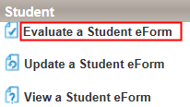
Search by Form ID (in the subject line of the email) or leave all the fields blank to see all pending eforms that need our approval. | 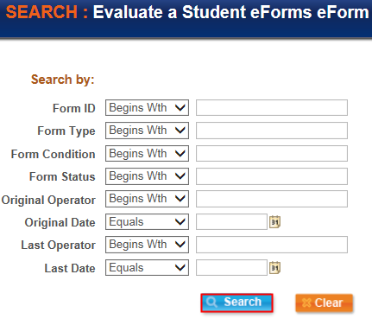
From the search results, select the form to review. | 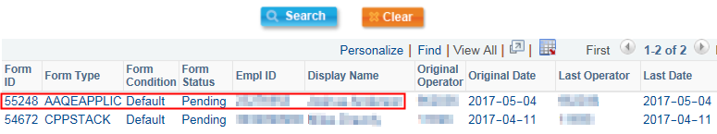
The introductory page displays.  Scroll down and click the Next button at the bottom of the page to see the details. | 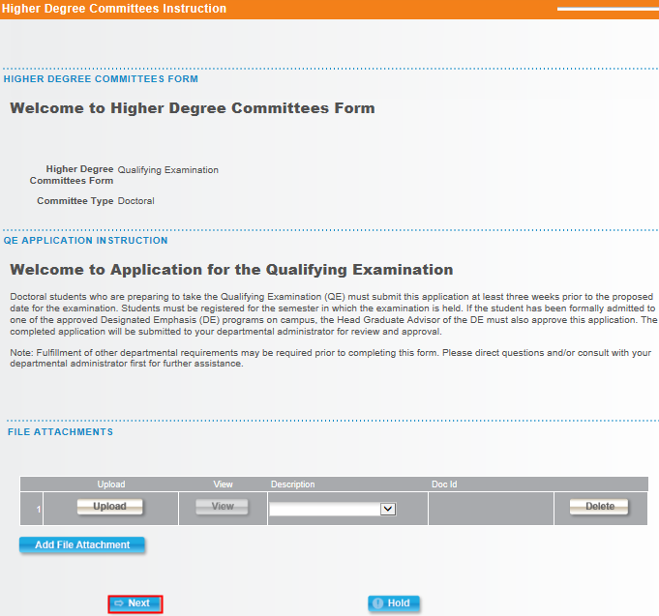
The QE Committees form loads.  The top portion contains the student’s information. | 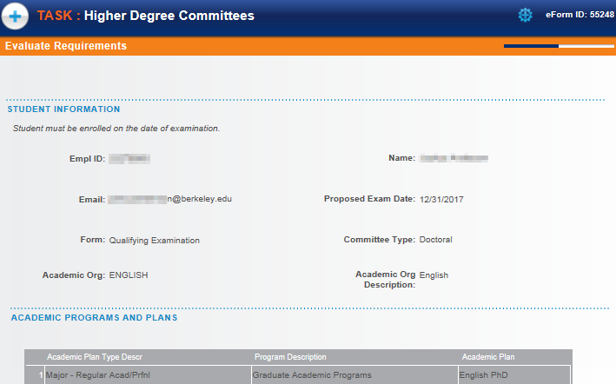
Review the Subject Areas. | 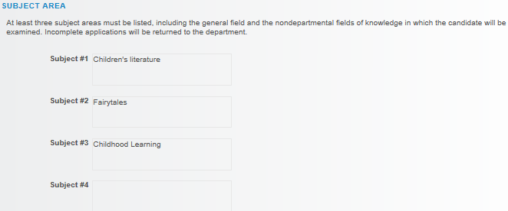
Review the Committee Members.  Remember to scroll to the right to check if someone is the Designated Emphasis member and to verify which members are in the Academic Senate. | 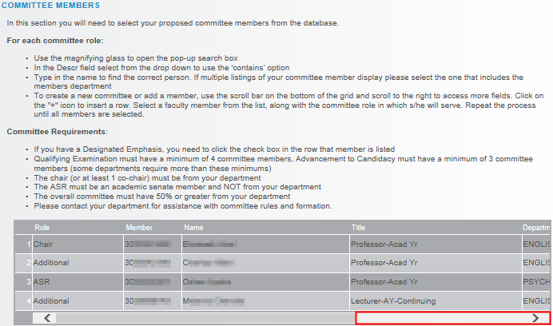
Note: Advisors do not have the ability to edit (add or remove) the committee members. | 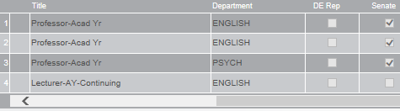
If a non-Academic Senate member was added, review the next two section. | 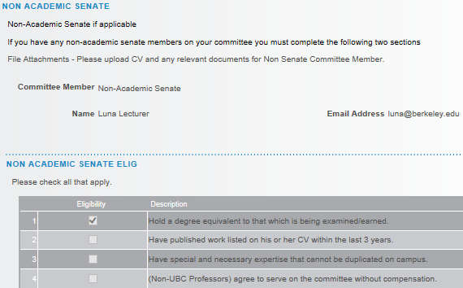
Review any Exceptions and File Attachments.  When you are ready, click the Approve or Deny button. In this example, we’ll approve this committee. | 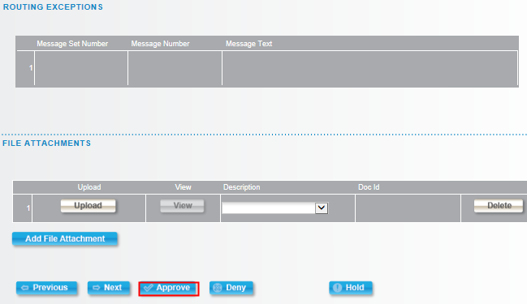
The transaction log will show that the GSAO has Approved the committee.  In our current example, this form will also be sent to Graduate Division to review and Approve. | 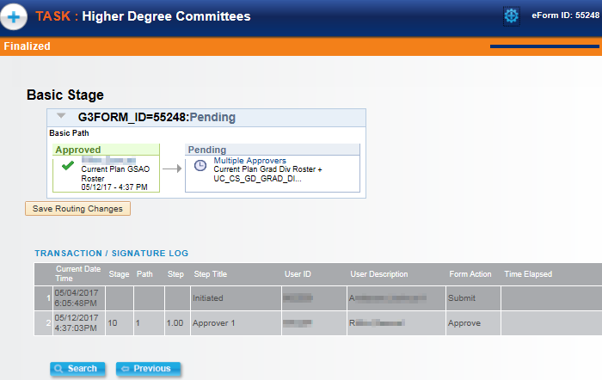
When all approvals have gone through, the student will receive an email notification. | 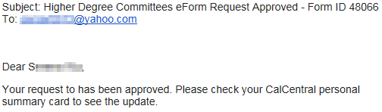

Support
For questions related to policy and procedures, students should refer to their department or to Graduate Division.
http://grad.berkeley.edu/about-us/contact/
For technical questions or assistance, please contact SIS Support.:
- Call 510-664-9000 (press option 6 to reach SIS support)
- Email: sishelp@berkeley.edu
- Submit a ticket: https://berkeley.service-now.com/ess/create_incident

