Viewing Payments
PATH: Main Menu > Student Financials > Charges and Payments > View Payments
The View Payments component displays all payments, financial aid, waivers, deposits and write-offs posted to a Customer Account. Additionally, there are tabs which show the how the payments were allocated and any reference numbers posted in the transaction.

Navigate to the View Payments page.  Main Menu > Student Financials > Charges and Payments > View Payments  Search for the student whose payments need reviewing. | 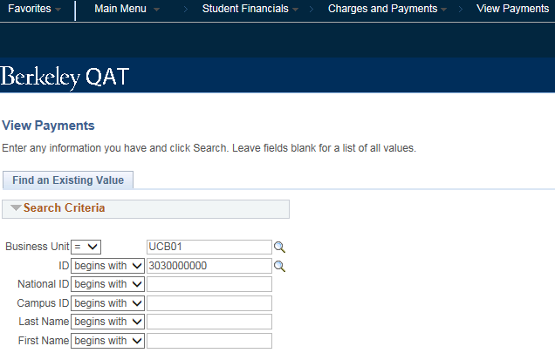
On the Payment tab, the Payment ID, Reversal indicator, Date Posted, Item Type, Term, Item Amount and Item Balance are displayed.  The Item Type is a description of the transaction.  If the Reversal indicator value is N, the payment has not been reversed.  On the left, is a Payment Allocation icon which is described below. | 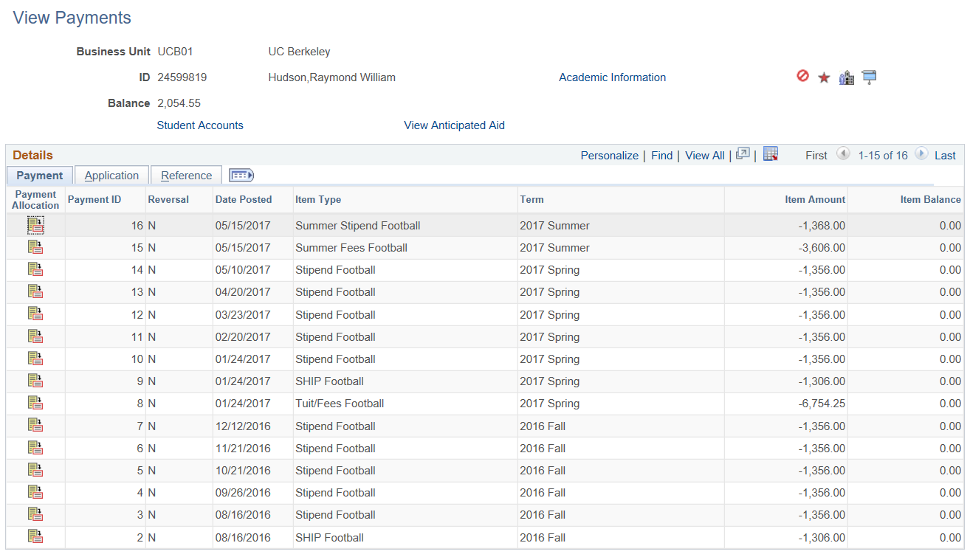

The Application tab repeats the Payment ID and also displays the payment allocation rules attached to each transaction.  The Charge Priority List determine what charges can paid and in what order.  Restrict (payment) to Account is a manual adjustment that can be done at the time the credit is posted to limit what the credit can pay.  Other options on this page are not used. | 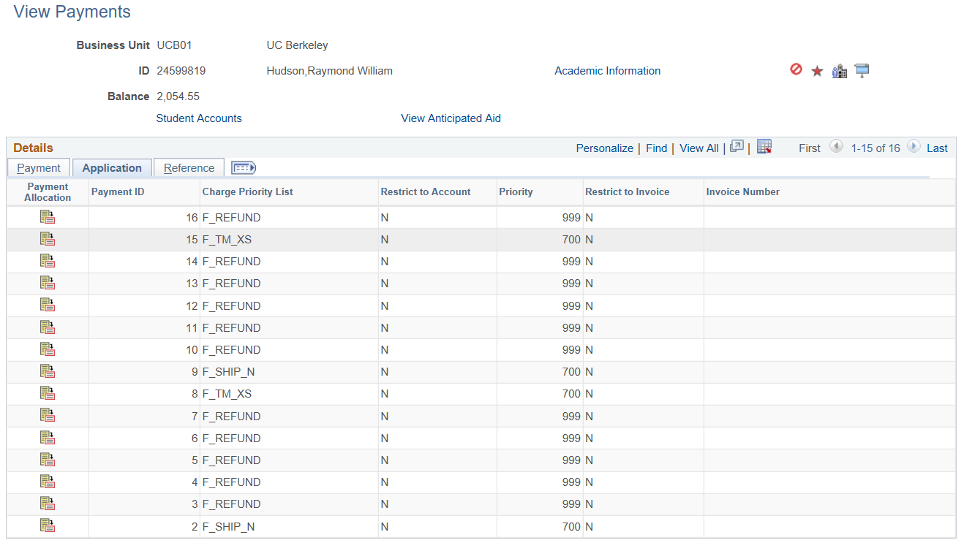
The Reference tab repeats the Payment ID and displays a Reference Number attached to the transaction.  Receipt Number is not used at UCB.  Contract Number shows payment plan/third party contract transactions.  Disbursement Date will also show. | 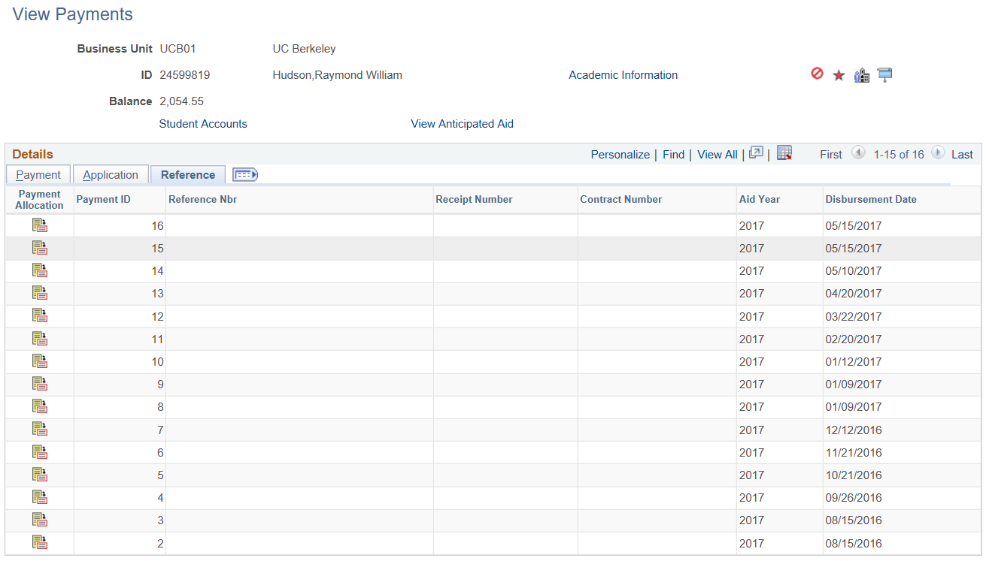

At the top of the page are 3 links: Academic Information, Student Accounts, and Anticipated Aid.  We will examine each of those below. | 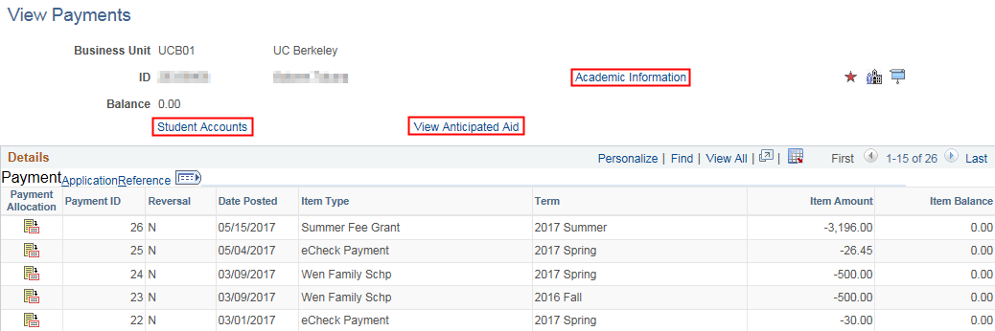
The Academic Information link displays personal data about the student.  The Career Term Data box shows academic data term by term. | 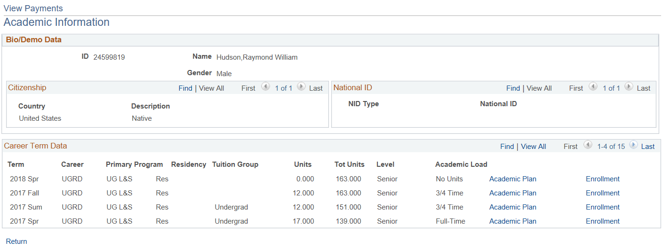
The Student Accounts link goes to the account page where the details can be viewed.  (See the Viewing Customer Accounts job aid for more information.) | 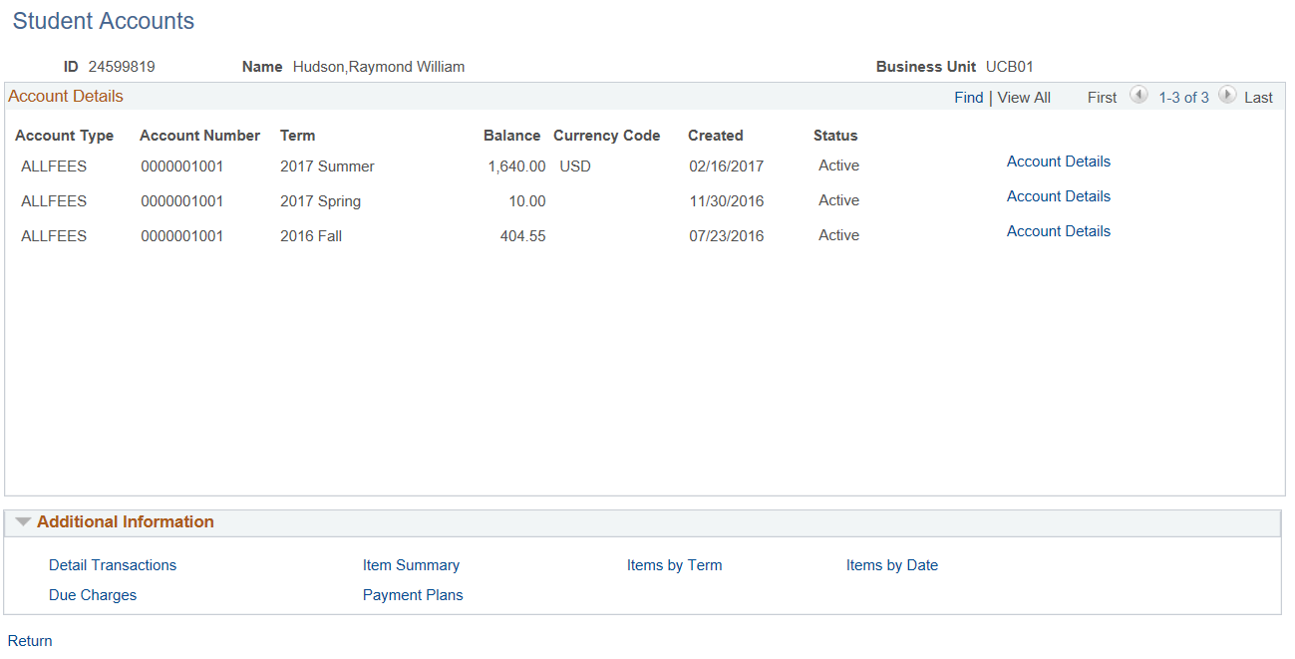

To see Anticipated Aid Details, click the View Anticipated Aid link.
Anticipated Aid is aid that has been awarded but not yet disbursed.
The Payment Allocation icon is is available on all tab pages.  Clicking on the icon for a transaction shows a Description of the charges paid by the credit item, as well as the Item Type Number that was used. | 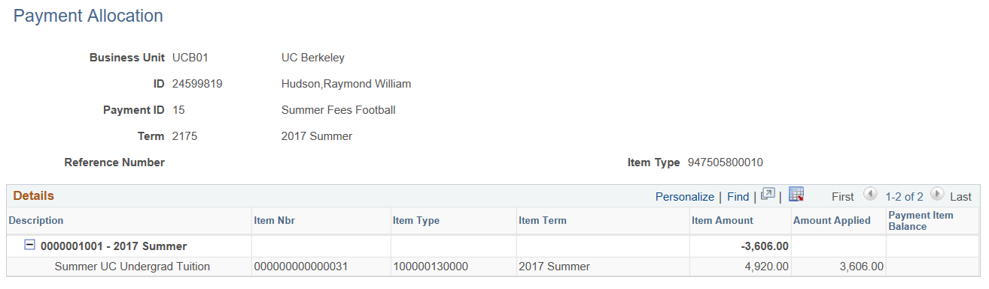

Support:
For questions or assistance, please contact SIS Support.
- Call 510-664-9000 (press option 6 to reach SIS support)
- Email: sishelp@berkeley.edu
- Submit a ticket: https://berkeley.service-now.com/ess/create-incident

